**Stock Analysis: Create a Buy Signal Filter using R and the Quantmod Package**

**INTRODUCTION**

Stock analysis is the evaluation of a particular trading instrument, an investment sector, or the market as a whole. Stock analysts attempt to determine the future activity of an instrument, sector, or market. Stock analysis is a method for investors and traders to make buying and selling decisions. By studying and evaluating past and current data, investors and traders attempt to gain an edge in the markets by making informed decisions.

The quantmod package for R is designed to assist the quantitative trader in the development, testing, and deployment of statistically based trading models. The quantmod makes modelling easier by removing the repetitive workflow issues surrounding data management, modelling interfaces, and performance analysis.

**OBJECTIVES**

* build a histogram that will assist in determining the threshold for the simple model Buy Signal.
* graph will then be created that will show both the buy signals and how it performed on the specified data.

**PROCEDURE**

In this project we use the data of tesla company and stock price of US stock exchange. Tesla, Incis an American electric vehicle and clean energy company based in Palo Alto, California. The company specializes in electric vehicle manufacturing, battery energy storage from home to grid scale and, through its acquisition of SolarCity, solar panel and solar roof tile manufacture

Initial we introduce the data of tesla into R studio. Then the daily change of stock in percentage. To get the change, we shift the vector values back a number series ie lag function. The ratio between close data and lag1 of close less one gives the daily change of stock price. Here we show the diagram where the stock price above 4%. If the price is more than 4% growth it shows buy signal.

**GRAPHICAL REPRESENTATION**

Closing stocking price of tesla with respect to the date.

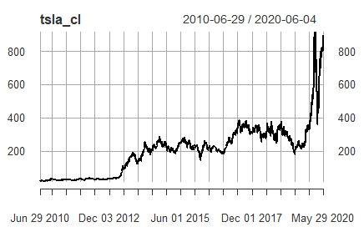

Daily change in the closing price of tesla .

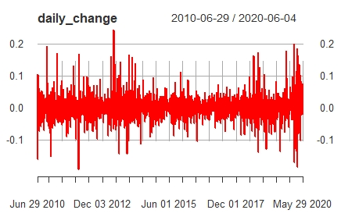

Histogramic representation of daily change in the close price

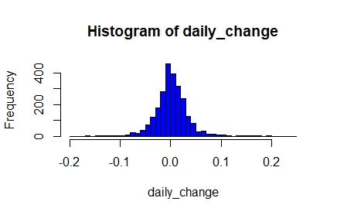

The main result is shown in below graph. It is the combination of close price of tesla company and its buy signal when it has more than 4% growth. The red line graph has only two signal either to buy or to sell. The peak position is the buy signal which is in position of one and the zero signal is selling. From the below graph we get a clear indication when to buy or sell the stock of tesla.

